WEEK 2 TASK
Responsive Web Prototype
for Digital Services
SevaSetu — Citizen Government Services Portal
Design Process • Wireframes • Responsive Strategy • Accessibility
Prepared for internship submission
1 September 2026

1. Executive Summary
SevaSetu is a responsive digital service portal concept designed to make common government-service tasks easier to discover, complete and track. The prototype prioritizes a clear information hierarchy, simple navigation, accessible forms, visible application progress and consistent feedback. The design is intentionally suitable for first-time users as well as regular users accessing services from desktop, tablet and mobile devices.

2. Project Goals & Target Users
Goal | Design response
Find services quickly | Search, popular-service cards and simple categories.
Complete applications confidently | Step-by-step forms, clear labels, examples and validation.
Understand application progress | Four-stage progress indicator and dedicated tracking page.
Work across devices | Fluid layout, scalable components and mobile-first adaptations.
Support inclusive access | Readable text, strong contrast, keyboard-friendly controls and clear errors.

3. Essential UI Components
- Header and primary navigation — Home, Services, Track Application and Help.
- Global service search — supports quick discovery without requiring users to understand departmental structure.
- Service cards — short descriptions, clear calls-to-action and recognizable visual hierarchy.
- Authentication — simple login/registration with accessible labels and recovery guidance.
- Application form — grouped fields, required indicators, inline validation and progress steps.
- Document upload — file requirements, upload status and replacement/removal controls.
- Review & submit — final summary before submission, consent/confirmation and application ID.
- Application tracking — status, timeline, expected next action and downloadable acknowledgement.
- Help & FAQ — plain-language guidance, contact options and troubleshooting.
- Footer — privacy, accessibility, contact, terms and grievance/help links.

4. Information Architecture & User Flow
Primary journey:
Home → Select/Search Service → Login/Register → Applicant Details → Documents → Review → Submit → Application ID → Track Status
The flow minimizes unnecessary decisions. Users can start from a service card or search, then move through a predictable four-step application process. A persistent progress indicator reduces uncertainty and helps users understand how much remains.

5. High-Fidelity Home Page Mockup
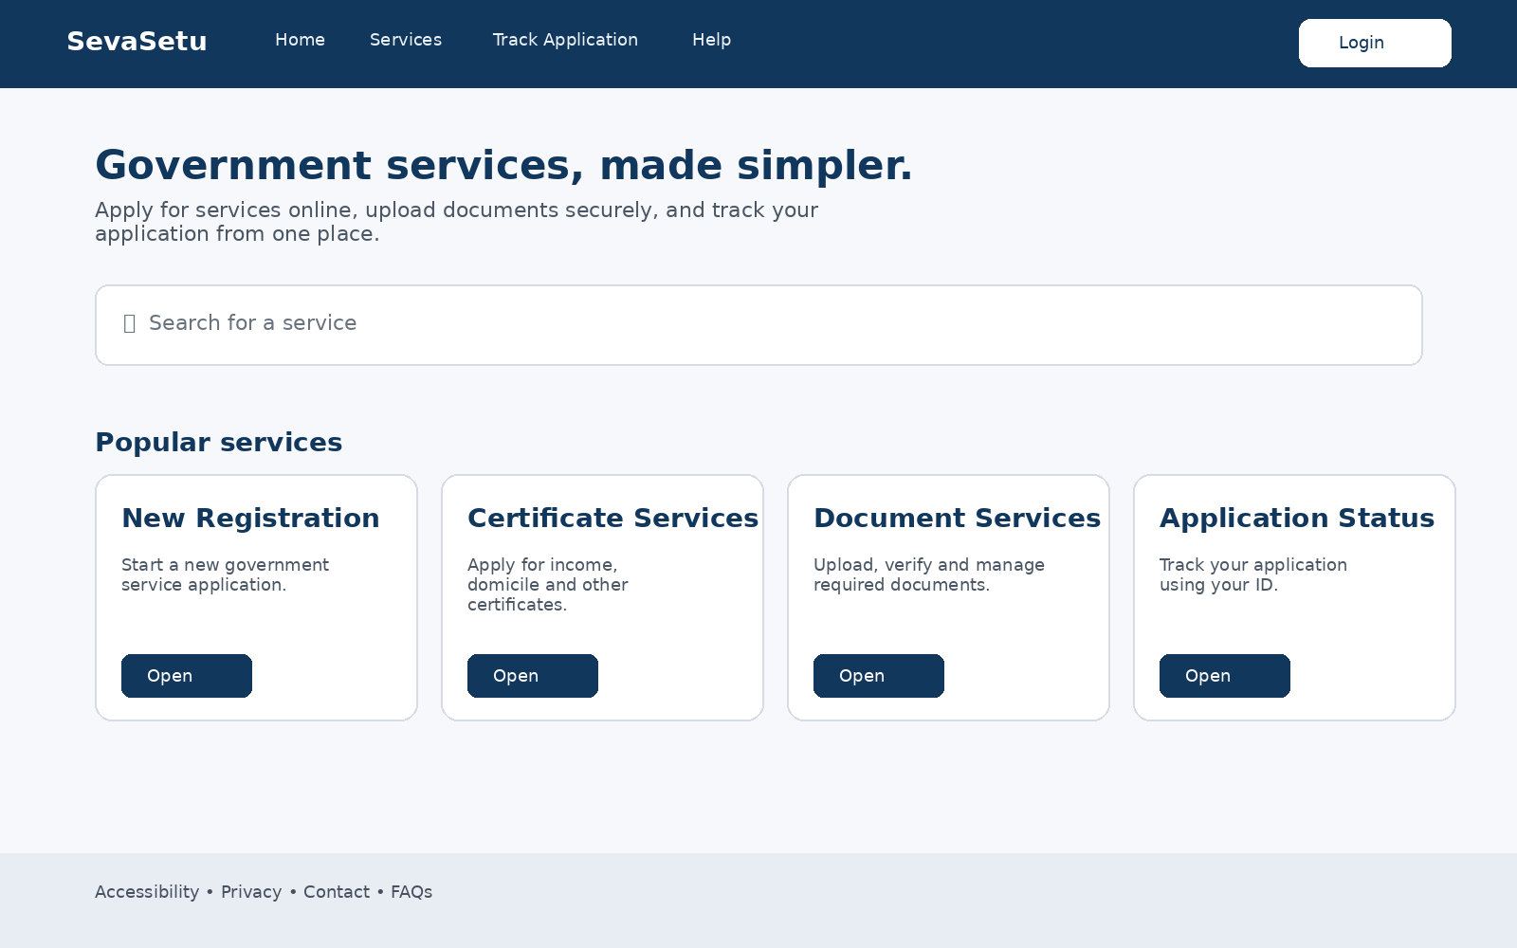
Figure 1. Desktop home page concept showing navigation, service search, popular services and accessibility-focused footer.

6. High-Fidelity Application Form Mockup
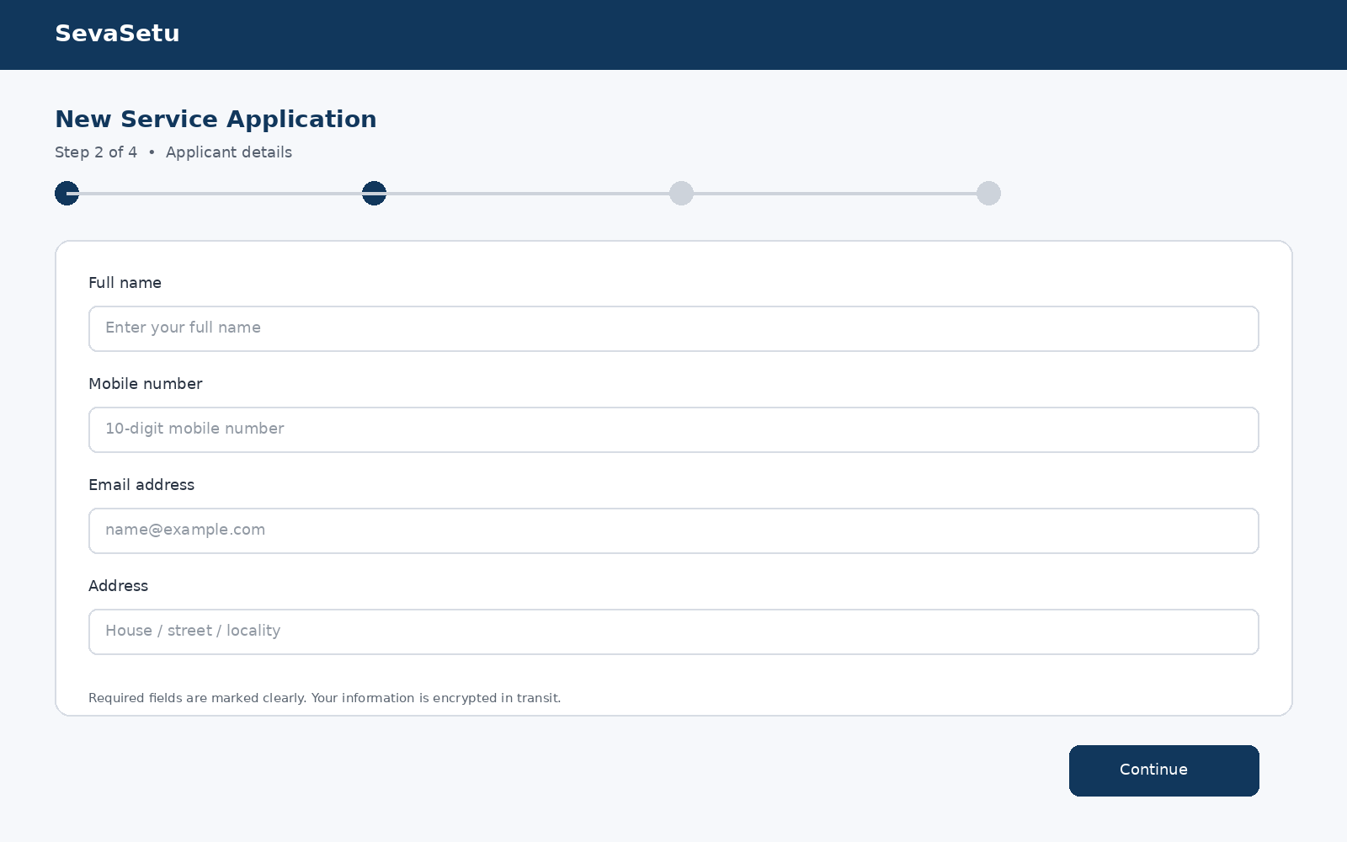
Figure 2. Application form concept with four-step progress, grouped fields, clear labels and primary action.

7. Mobile Responsive Mockup
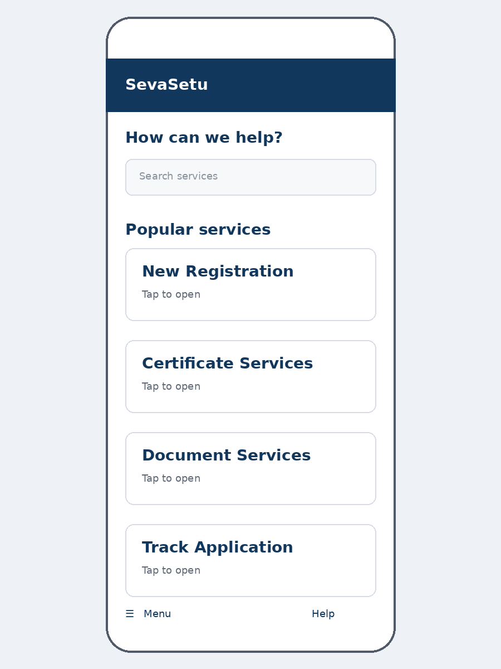
Figure 3. Mobile adaptation: stacked service cards, simplified navigation and touch-friendly controls.

8. Responsive Design Strategy
Breakpoint | Layout behavior | Key considerations
Desktop | Multi-column cards and full navigation | Use wide content area without excessive line length.
Tablet | Reduced columns and flexible spacing | Keep controls comfortable and preserve hierarchy.
Mobile | Single-column stacked layout | Collapse navigation, enlarge tap targets and keep forms readable.
Implementation principles: use a fluid grid, relative sizing where practical, flexible images, responsive typography, CSS media queries and reusable components. Content should reflow rather than requiring horizontal scrolling. Form controls should remain usable with touch input and zoom.

9. Accessibility & Usability
- Semantic structure: headings and landmarks should communicate page structure to assistive technologies.
- Keyboard access: every interactive control must be reachable and have a visible focus state.
- Color and contrast: never communicate status by color alone; pair status colors with text or icons.
- Forms: every field needs a persistent, descriptive label; errors should explain what went wrong and how to fix it.
- Readable content: use plain language, adequate line spacing and scalable text.
- Touch targets: interactive elements should have generous spacing and comfortable hit areas.
- Feedback: show loading, success, failure and upload states so users always know what happened.
- Error prevention: validate progressively, preserve entered data and provide a review step before final submission.

10. Design Rationale
The visual direction uses a restrained government-service aesthetic: a deep blue primary navigation area, a light neutral page background and white content surfaces. This creates strong separation between navigation and task content while keeping the interface professional. Cards make services scannable, while the large search field supports users who know what they need but do not know which department provides it.
Form screens use a single dominant task per step. The progress indicator makes the multi-step process visible without overwhelming the user. Primary actions are visually prominent, while supporting information is placed close to the field or task it explains.

11. Usability & Trust Considerations
- Display official-looking service names and concise descriptions rather than technical department terminology.
- Show exactly what documents are required before upload begins.
- Provide an application/reference ID immediately after successful submission.
- Use confirmation and review screens to reduce accidental submissions.
- Explain privacy and data-use information in plain language at the point where sensitive information is requested.
- Keep navigation and terminology consistent across all service pages.

12. Prototype Evaluation Checklist
Evaluation area | Acceptance check
Creativity | Modern, trustworthy government-service interface with clear visual hierarchy.
Responsiveness | Home, cards and forms reflow correctly from desktop to mobile.
Documentation | Design decisions and user flow are explained with visuals.
Accessibility | Keyboard, contrast, labels, errors and readable content are considered.
Usability | Users can discover a service, submit an application and track it with minimal confusion.
Coherence | All screens use the same navigation, typography, spacing and interaction patterns.

13. Conclusion
The SevaSetu prototype translates the Week 2 requirements into a coherent responsive digital-service experience. The design focuses on the practical needs of public users: finding the right service, completing a form without confusion, submitting documents, receiving confirmation and tracking progress. Its responsive structure and accessibility considerations provide a strong foundation for the next stage of development into an interactive web prototype.

Appendix A — Suggested Prototype Screen Set
- 01 — Home / Service Discovery
- 02 — Services Directory
- 03 — Login / Registration
- 04 — Applicant Details
- 05 — Document Upload
- 06 — Review & Submit
- 07 — Application Confirmation
- 08 — Application Tracking
- 09 — Help / FAQ
- 10 — Mobile responsive variants

